EC2-challenge

* Launch one **EC2 instance** using **Amazon Linux 2**.
* Install **Docker**.
* Steps: yum install docker
* Syetmctl start docker
* Systemctl enable docker

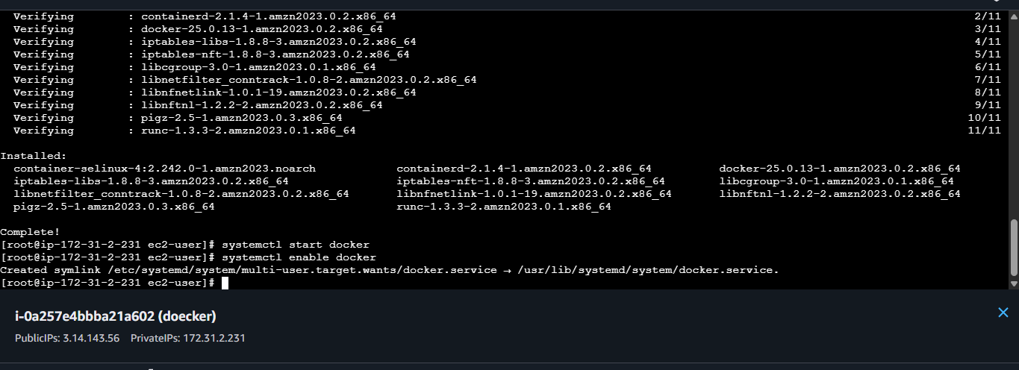

* Install **Jenkins**.

First I install java version to support the< jenkins sudo yum install java-17-amazon-corretto –y>

#then check the java version which support Jenkins.

#then install jenkin <sudo dnf install -y Jenkins>

#systemctl enable Jenkins<sudo systemctl enable --now Jenkins>

#then status check<sudo systemctl status Jenkins>



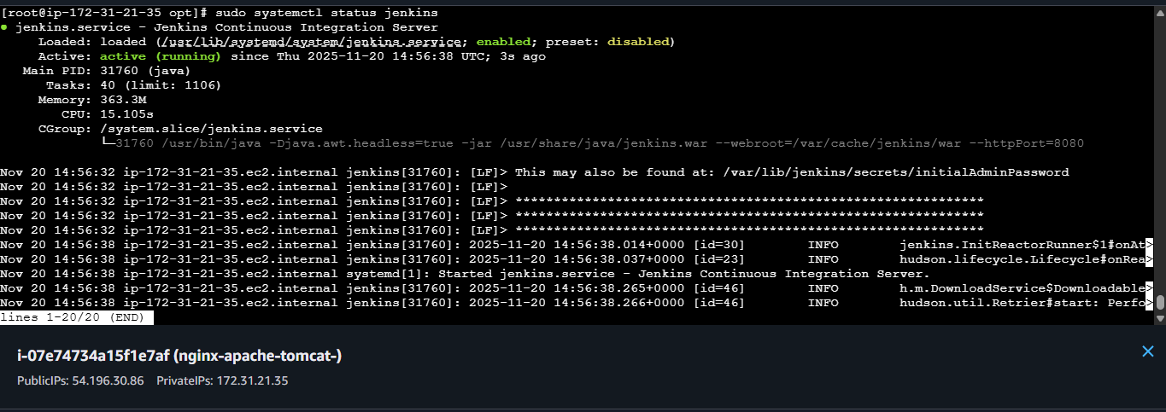

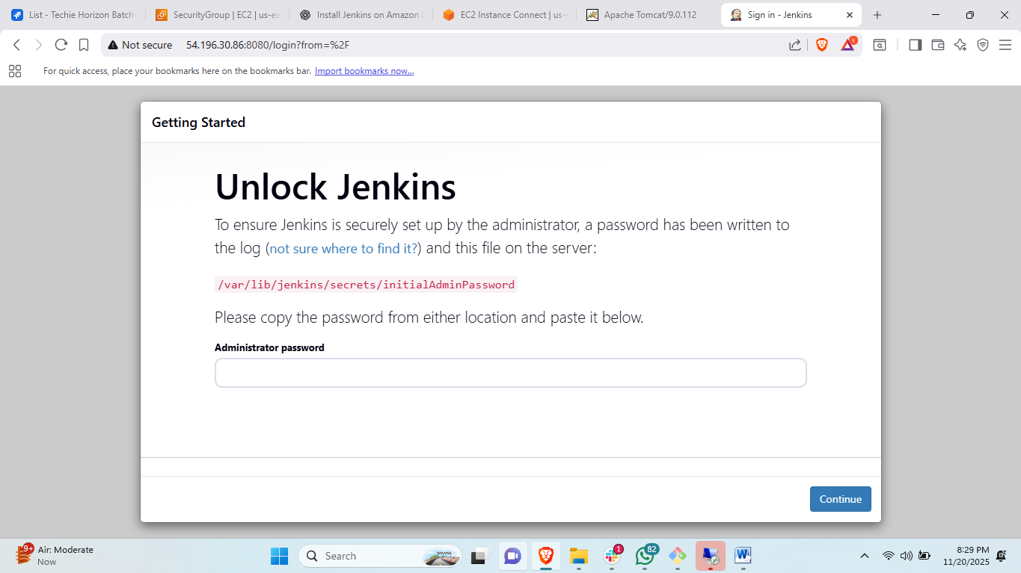

* Install **Apache**.
* Steps: first update –y
* Install apache by using this command<Yum install httpd –y>
* Then change port number of apache:
* <vi /etc/httpd/conf/httpd.conf> change listen 80 to 81
* Then save exit and <systemctl enable httpd><systemctl start httpd>
* Then check by copy public ip:81 in browser.



Install apache:httpd:on port nuber 81

* Install **Nginx**.
* Steps: first yum update –y
* Yum install nginx –y
* Then change port number vi /etc/nginx/nginx.conf.
* Edit where ever the port number is 80 to 82
* Then start nginx
* Systemctl start nginx
* Systemctl enable nginx

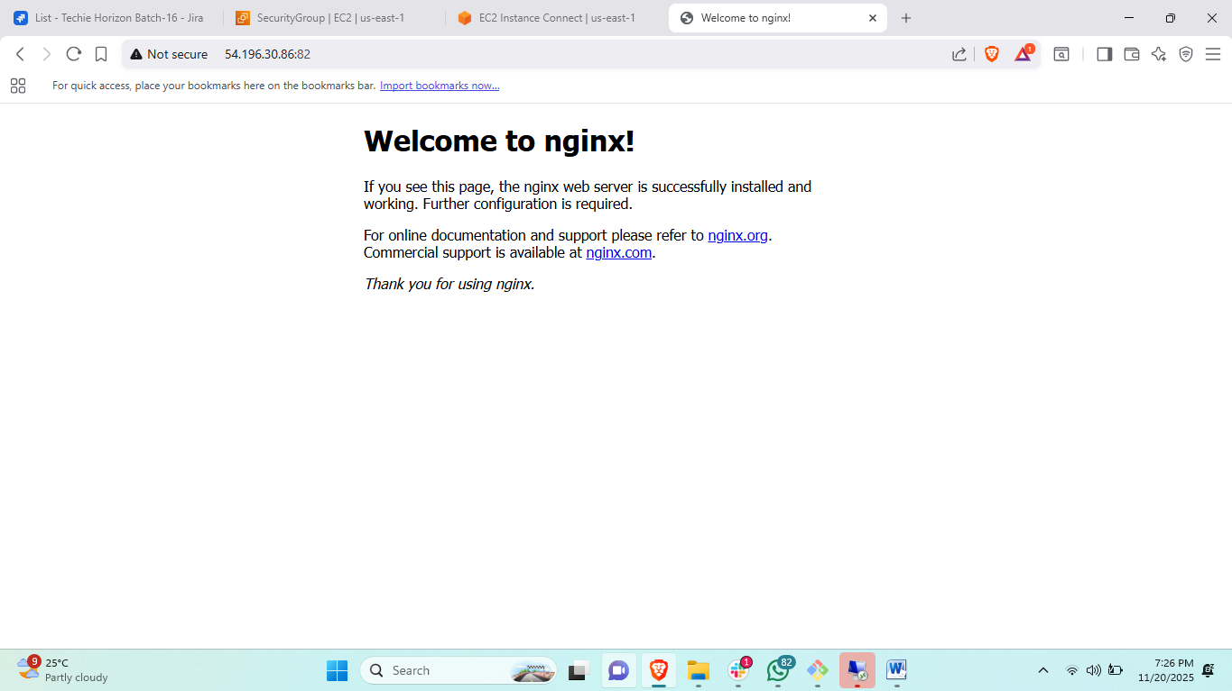

Setup and run nginx on port no:82

* Install **Apache Tomcat**.
* Steps to setup tomcat at port number 8082
* First install java for support the apache tomcat
* Need to install java 17*<yum install java-17*>
* Then change directory for deployment<cd /opt>
* Then <wget tomcat URL from crome>
* Then untar the file tar xvf “apache tomcat”
* Cd /tomcat/conf
* Vi server.xml
* Change port number where ever 8080 cahnge to 8082 then save file.

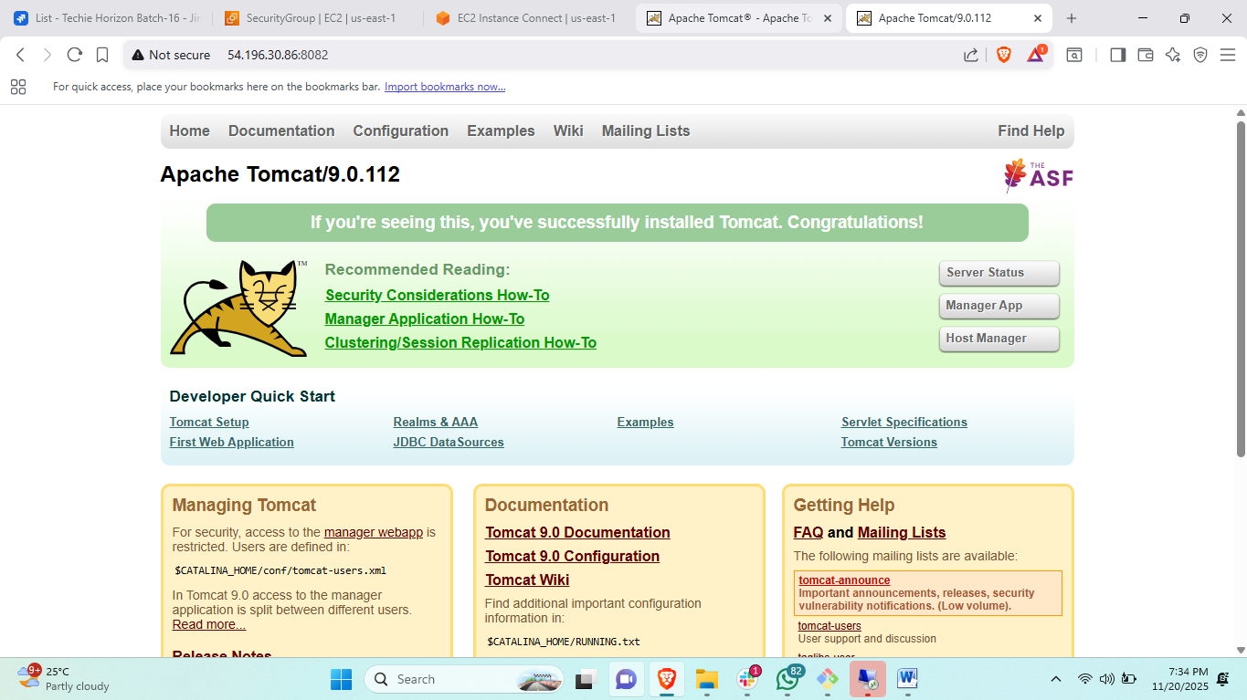

Install and setup tomcat on port number:8082

Everything needs to be setup and running on the **same EC2**.  
You can change the port numbers as required.  
Need to complete this **before logging off**.